Africa
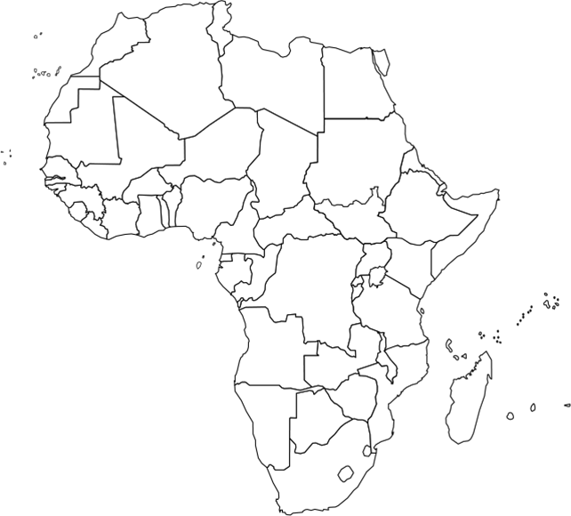
Write the name of the country in the spaces provided

